LEARNER MANAGEMENT INFORMATION SYSTEM GUIDELINE:
MANDATORY GRANT APPLICATION
SKILLS DEVELOPMENT FACILITATOR USER PROFILE
INTRODUCTION
This guide has been developed by the Service SETA to guide skills development facilitators within the services industry to submit the Workplace Skills Plan, Annual Training Report, Pivotal Training report and Pivotal Training Plan on the Learner Management Information System (LMIS) and gain access to Mandatory Grant applications.
Please note the LMIS is not only limited to Mandatory Grant applications, but is utilise across the various SSETA units, please ensure for the purposes of this process your register/have registered as user type Skills Development Facilitator.
The LMIS has three phases for the submission of the Mandatory Grants application. Kindly ensure that all three phases have been completed and you have received an automated response form the LMIS confirming your Workplace Skills Plan and Annual Training Report submission has been successful.
The three phases on the LMIS are:
- The Pre-Application Phase:
Skills Development Facilitator Registration
- New skills development facilitator
- Logging into existing skills development facilitator profile
Company Registration
Request for an extension
- Application Phase:
Trade Union
Hard to fill Vacancies
Skills Gaps
- Submission Phase:
Employee Registration
Creation of Intervention
Creation of Class
Enrolment
Document upload
Submission

Table of Contents
1. Pre-Application Phase: 3
1.1. Link to LMIS: https://lmis.servicesseta.org.za 3
1.2. Creating a new skills development facilitator profile 4
1.3. Logging into an existing skills development facilitator profile 9
1.4. Company Registration 10
1.5. Request for an extension 12
2. Application Phase 13
2.1. Union Representation 13
2.2. Hard-to-fill Vacancies 14
2.3. Skills Gaps 14
3. Submission Phase 16
3.1. Employees 17
3.2. Interventions 18
3.3. Training Completed and Planned 23
3.4. Excel Bulk Upload On Lmis 23
3.5. Compulsory Documents 25

MOST IMPORTANTLY – READ

Pre-Application Phase:

Link to LMIS: https://lmis.servicesseta.org.za
- Use the above link can be used to gain direct access to the LMIS login and registration page.
- The skills development facilitator profile is protected by POPIA and belongs to the skills development facilitator who created the profile – new skills development facilitators may not amend the profile but must create their own.
- Only new skills development facilitators need to create a new skills development facilitator profile on the LMIS.
- Existing skills development facilitators must use their previously created credentials.
- All skills development facilitator log in issues must be sent to applicationsupport@serviceseta.org.za and cc wspdocs@serviceseta.org.za
- To update your skills development facilitator profile complete and submit the Skills Development Facilitator Profile Amendment Document and submit to wspdocs@serviceseta.org.za for Technical Support to make the amendments. Skills development facilitators should not be making any amendments on skills development facilitator profiles.
- Skills development facilitator profiles on the LMIS belong to the individual and is protected by POPIA.
- The LMIS will not allow one skills development facilitator with to create more than one skills development facilitator profile.
- You can also join the SERVICES SETA MS TEAMS WALK IN OFFICE for technical support:
https://teams.microsoft.com/l/meetup-join/19%3ameeting_MzkzZjhiOGItN2MxNi00MDkzLWFiYWUtYTZlM2VlMThiODFi%40thread.v2/0?context=%7b%22Tid%22%3a%22e6cf5c66-c2fc-4ed2-90ee-23ae191f6885%22%2c%22Oid%22%3a%2282f20045-a880-4eec-a460-644b2cf6681b%22%7d

Creating a new skills development facilitator profile
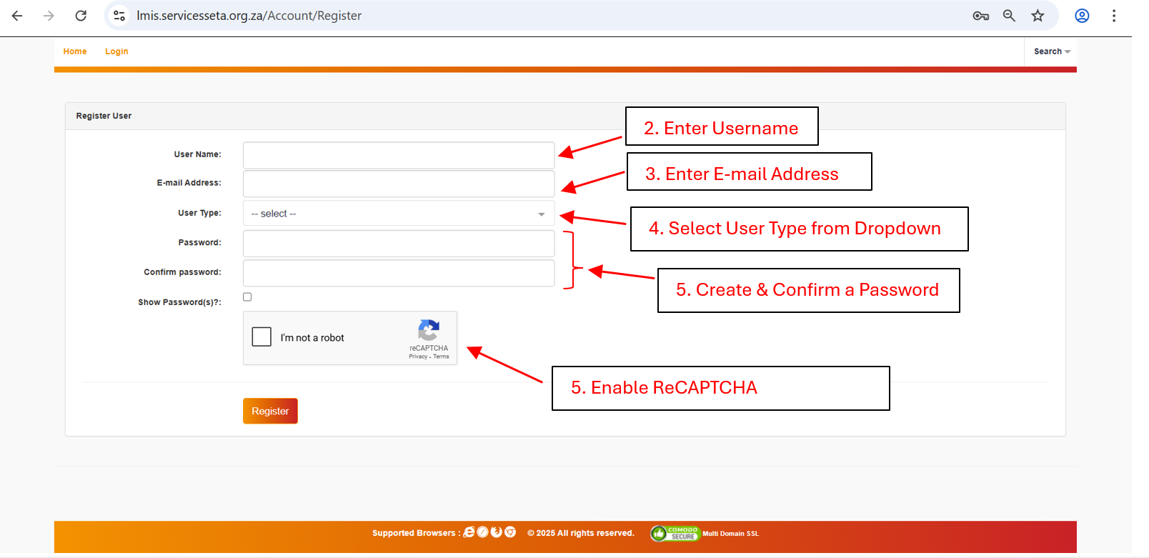

    - For first time users an LMIS account will need to be created, click the “Register” button to be taken to the below registration screen.
    - The account must be created with the user type of “Skills Development Facilitator”.
    - Enter a username (this needs to be unique), you will be prompted if the name is not available.
    - A password will also need to be created and confirmed.
    - Complete the reCAPTCHA image to confirm authenticity.
    - Click the “register” button.
    - Once registration is complete, an email will be received to your entered email address with an activation code.
    - Upon first login to the LMIS you will need to enter this activation code and proceed to activate the account.

    - The details of the Skills Development Facilitator must be entered into the SDF details screen below, these are the details of the individual completing the submission.
    - Click “Save” at the top or bottom of the screen to save the details and proceed.
    - Complete the next set of SDF details, questionnaire, and work details, once all fields are completed you can click “Save” to save the details to the LMIS system. You will be able to proceed to the company registration section once the SDF profile has been completed.
    - Once the information has been successfully completed and saved, a message indicating the data is saved successfully and the information can be viewed.
    - The WSP Summary page is a list of all WSP ATR registration the SDF has engaged, once the details of a company have been saved on main company details, they will appear here where the submission can be proceeded with. The companies will no longer appear in company registration if the company is already linked (companies are automatically delinked at the end of each submission period).

Logging into an existing skills development facilitator profile
    - If an SDF LMIS profile has been created in the past, then the profile can be logged into for the submission.
    - If any details of the SDF have changed then they can use the “Edit” button to update the information and “Save” to confirm the new data once completed. Note if a new SDF has been appointed then a new profile for the SDF should be created.
    - If the profile has become inactive then an email with the username and email address of the profile should be sent to applicationsupport@serviceseta.org.za requesting the account be activated, a notification will be received once this is complete.
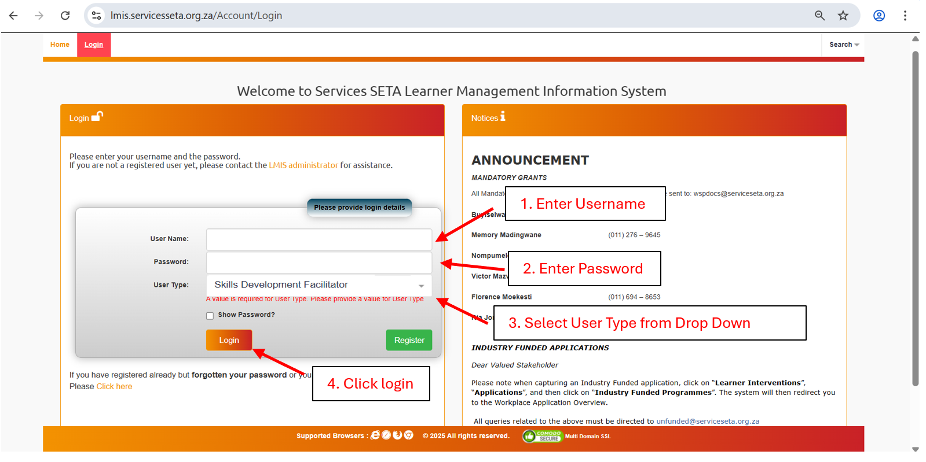

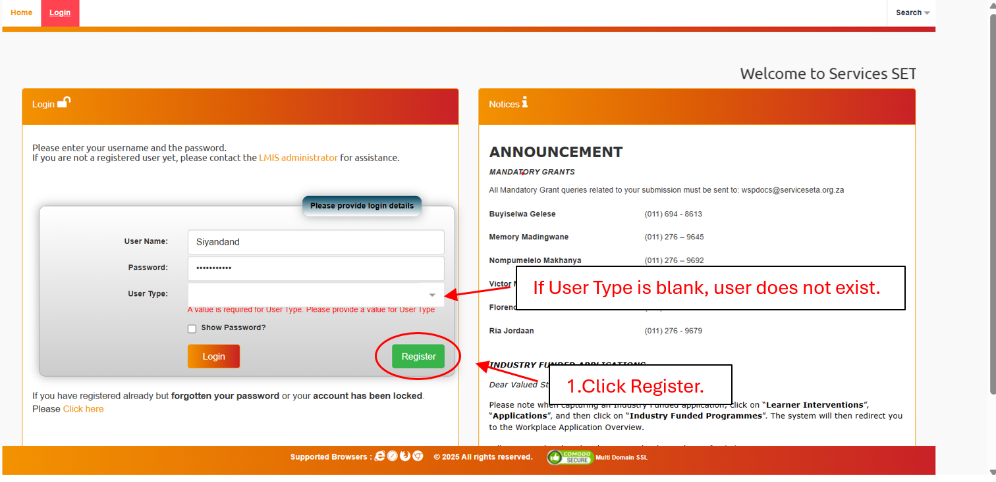

Company Registration
    - When the SDF is ready to link an SDL number to their profile for submission purposes, the “Company Registration” button available on the SDF details page and the WSP summary page, this will take you to the Main Company Details page.
    - Company registration will request for a SDL number to be entered, or a non-levy paying company registration to be completed (using the company’s registration number and details).
    - Once the SDL number is entered or Non-levy paying registration completed, the main company details page should auto populate with the company name and trading name, and any other details available from the SSETA database and previous submission information, this should be updated and saved if the details are incorrect. Where details are incurred that cannot be edited (such as company name) a request will need to be made to the SSETA to have these amended.
    - Contact information, banking details, and number of staff need to be inputted/updated, as well as the completed declaration document (available on the SSETA website – LINK) once the details are completed in full the SDF can save the details, and this will add the company to the SDF’s profile.
    - Once the main company details are saved, the company will no longer be able to be accessed using the company registration function, but will be added to the WSP Summary page, were the option to continue with the submission is available.
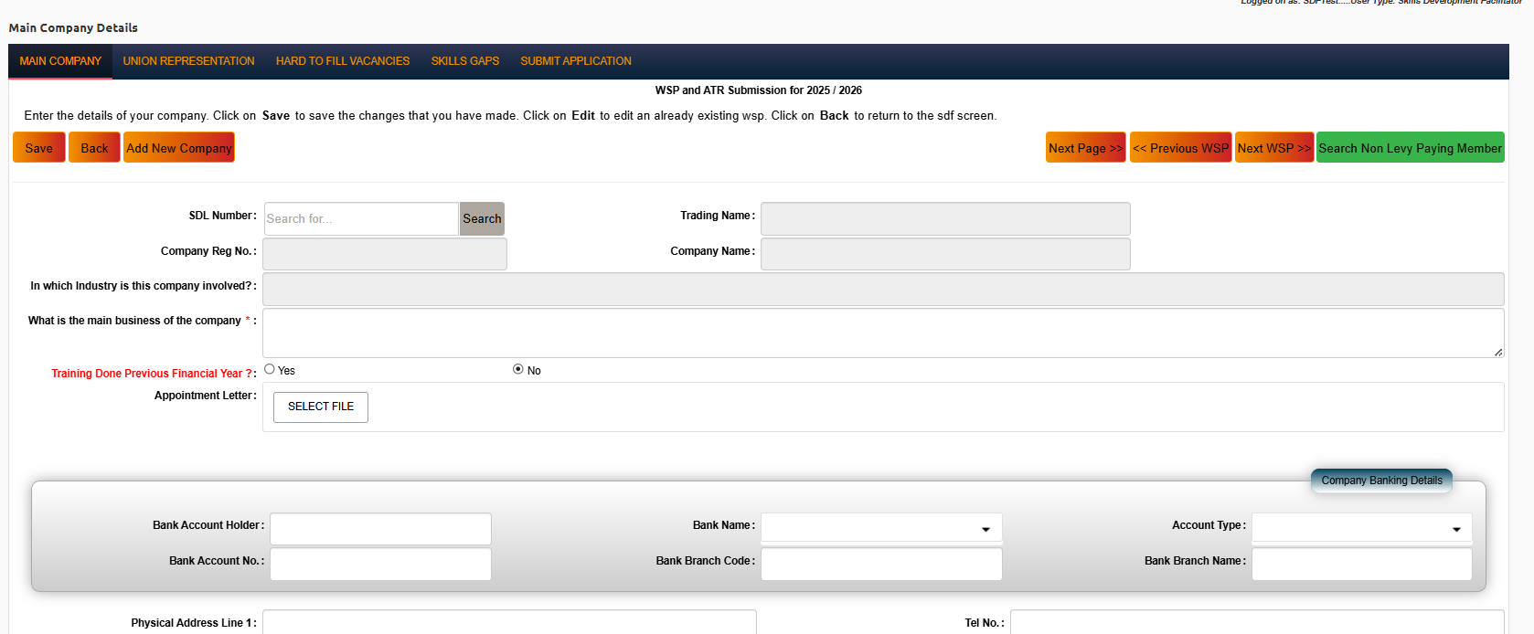

Request for an extension
    - All requests must be submitted on the LMIS after the SDF registration and Company Registration process is completed. The System will only then provide the option to load an extension request.
        - Applications for an extension is subject to approval by the SSETA Accounting Authority
        - All applications must be submitted on or before 30 April
        - Approved extension may not exceed one month from the deadline date (Extension Deadline 31 May).
    - Navigate to the WSP Summary Page.
    - After the Main company details have been saved and the company appears here, the Request WSP Extension option will appear on the far-right hand side of the option menu.
    - Click this option to open the Extension request window below.

    - The company details (SDL Number, Registration number, training name) should appear in the window
    - Type in a motivation for why the extension is needed in the motivation window.
    - In the authorisation letter section, a formal extension request letter, on a company letter head (of the applicant) and signed should be uploaded.
    - Click the “Add” button to request an extension for this company with the loaded details, and the request should appear in the table below the “Add” button.

Application Phase
The remaining 3 tabs will be unlocked once the main company details are saved, these need to be completed for the registration phase of the Mandatory Grant submission to be completed.

Union Representation
    - The Union Representation applicable only if the employer has a registered trade union agreement in place.
    - Capture the shop stewart details and press the save button. The details must appear in the bottom window.
    - If no trade union agreement is in place leave the fields untouched and move to the next page.

Hard-to-fill Vacancies
    - The Hard – To – Fill Vacancies (HTFV) and Skills Gaps are part of DHET’s Workplace Skills Survey. The section requires employers to provide the HTFV by the 6-digit OFO occupation titles.
    - The drop-down menu contains all active OFO codes (2021), the 6-digit number can be typed into the field and the options match will be searched in the list of codes.
    - Each OFO code match a HTFV should be saved before the next is selected, these will appear in a list once saved below the search field.
    - If the field in not applicable, the “Hard to fill vacancy not applicable” tab must be selected. Under reason why not applicable the appropriate option must be selected and press the save button. It must appear in the bottom window.
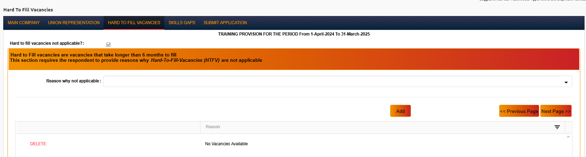

Skills Gaps
    - A skills gap refers to skills that an employee does not have to carry out job tasks competently. It also referred to as “top-up” skills or a high-level presentation of the WSP. This section requires the employer to provide information on Skills Gaps of employees.
    - The Skills Gaps page requires the SDF to select the major OFO code group that the skills gaps exist in, and then a critical skills group of the skill gap identified. The critical skills list is based on the skills group selected. A reason from the pre-set “reason for skills gap” must also be selected and the data set saved, once it is saved it will appear in the window below, and additional skills gaps can be identified.
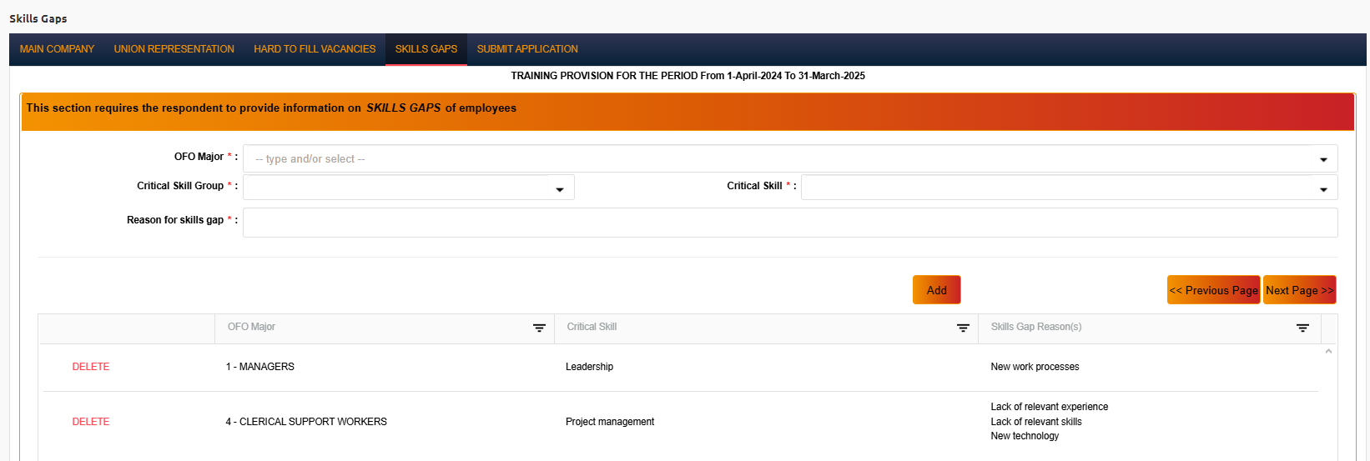
    - The final step of Registration Phase to proceed with the submission of WSP and ATR is to confirm the previous information, a summary of the pages is listed on the Submit Application.
    - Once all pages indicate a “Y” (Union representation can be N if no trade union agreement exists). To proceed to complete the WSP and ATR data the “Submit Application” button must be pressed, this prompt the user to confirm they would like to move to the WSP / ATR submission page as the registration information cannot be updated past this point.
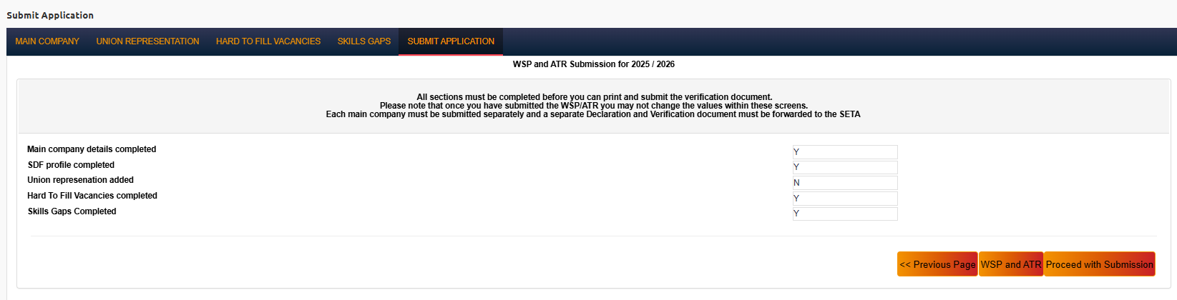

Submission Phase
The submission phase consists of three stages:
EMPLOYEES
Biographical data must be provided for the below listed employee categories:
        - All personnel appointed by the employer at the time of submission
        - All terminated personnel that were trained during the ATR period
        - All unemployed learners on occupational learning programmes
INTERVENTIONS AND CLASSES
The below four steps must be completed:
        - Intervention
        - New Class
        - Enrol Class
TRAINING COMPLETED AND PLANNED
Auto populated from class enrolment
This section can either be completed with direct capturing on the LMIS or via bulk excel upload. If a skills development facilitator’s excel skills are not strong the Services SETA recommends that they make use of the direct capturing option on the LMIS.
Should the skills development facilitator wish to make use of the bulk upload option the below template must be used:
        - MG_SOP_ANNEX_05_25-MANDATORY GRANT EMPLOYEE PROFILE TEMPLATE-Final
The below guidelines must be used to accurately populate the Employee Template:
        - MG_SOP_ANNEX_MANDATORY GRANTS_CODE SHEET
        - d. SERVICES SETA 2025-26 MANDATORY GRANT_EMPLOYEE SPREADSHEET GUIDELINE
The below guideline must be used for all accurate information data
        - e. MG_SOP_ANNEX_06_25-WSP AND ATR INTERVENTION MATRIX

DIRECT CAPTURING ON LMIS

Employees
    - Biographical data must be provided for the below listed employee categories:
        - All personnel appointed by the employer at the time of submission
        - All terminated personnel that were trained during the ATR period
        - All unemployed learners on occupational learning programmes
        - All employees within the organisation, including any external parties that will be reported on the ATR or WSP will need to be captured.
There are various ways to load the employee details:
    - Add new employee: This will open a window prompting the user to capture all required information on each employee/beneficiary. All information needs to be completed accurately as per the individuals’ details. Once the information has been inputted, clicking save will add the data to the employee page, and options to view (open the information for editing) or delete the record is available. Should any required information be omitted or is not in line with the required options an error will be displayed and will not be saved until corrected.
    - Copy From Last Year: This option is only available for organisations that have completed the previous year’s submission on the LMIS. Selecting this will pull all previous employee data submitted to your current submission. Should any individual’s details need to be amended the view option can be selected and edited before being saved and updated. Details that are no longer required can be deleted, and any new entries can be added using the Add New Employee option.

Interventions
The below three steps must be completed:
        - Intervention
        - New Class
        - Enrol Class
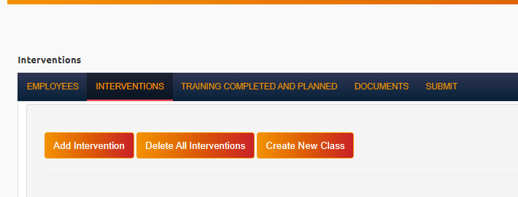

    - Interventions, select an option for the intervention (WSP or ATR) and complete the required information.
    - Create a new Intervention and save it.
    - Click to Create New Class.
    - Choose the intervention from the list of interventions that have been added (via the WSP and ATR options). All ATR interventions must have
    - Choose a name for the class (can use the same as the intervention name it is relating to).
    - Intervention Status will be Planned if WSP only and Achieved and Enrolled for ATR.
    - Click Save and the list of classes should be listed at the bottom of the screen (under the intervention capturing window).

Classes

    - At the top on the Interventions Page select Create New Class and link the class to the respective intervention.
    - Select the learner’s employment type (18.1 Employed & 18.2 Unemployed)

    - Select the Intervention Status:
        - WSP Intervention Status – Planned
        - ATR Intervention Status – Enrolled/Achieved
    - State the mode of learning from the drop-down box.
    - Leave the dates as is and do not amend same.
    - Press the save button.
Enrol Intervention Class
    - Scroll down and click Enrol Class. This is where you will Enrol Employees to the Classes as per the Intervention attended.
    - Select Employees Enrolled from the Employee drop down button and select Enrol Employee.
    - Employee will be loaded and appear on the Employee intervention page for information purposes, the number on the submit page summary should also increase as the employees are linked to training.
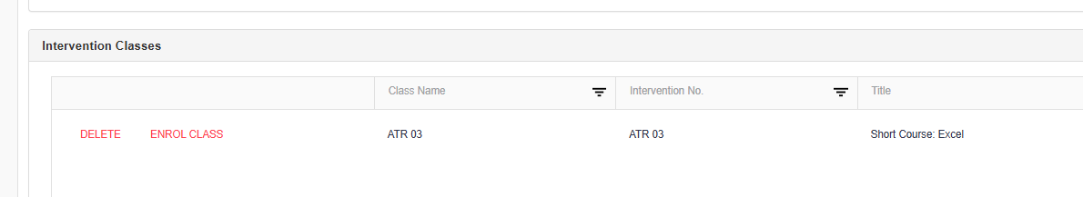

Training Completed and Planned
    - The training completed ad planned page is where you can see the employees that have been linked to which interventions and whether they are part of the WSP or ATR. The information cannot be edited on this tab, the data can be exported to excel using the “Export” option.
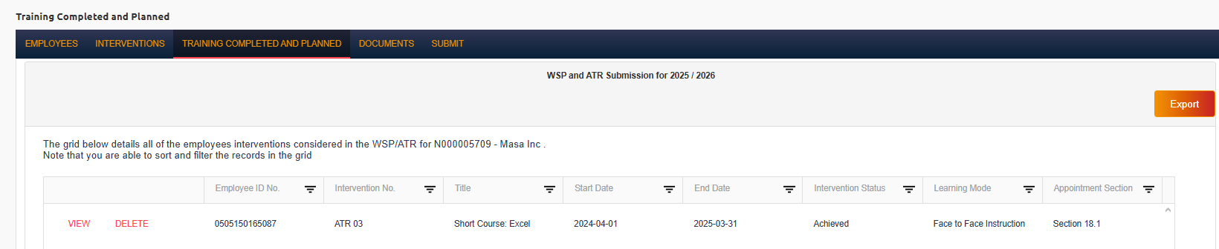

Excel Bulk Upload On Lmis
    - The LMIS allows employees, interventions and classes through:
        - Direct capturing on the LMIS.
        - Using the bulk excel option making use of MG_SOP_Annex_05_25-Mandatory Grant Employee Profile Template-Final.
Should the skills development facilitator opt to make use of the bulk excel option we urge the user to follow the guidelines provided to accurately capture their data for proper submission.
The top rows of each sheet marked in “Orange” are the instructions to be followed for that specific collum.
The Employee Profile template consists of 3 sheets:
        - Employees
        - Training Interventions
        - Training Competed and Planned
    - Once the template is completed the Employee Template can be uploaded onto the LMIS on the Employee Tab with the “Import From Excel” tab.
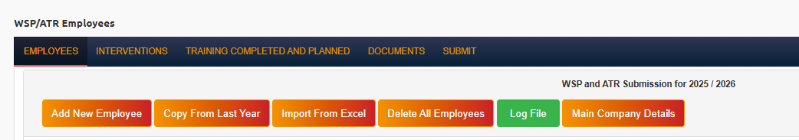

Compulsory Documents
    - Before the submission can be completed, the verification Documents for banking details i.e. formal bank account confirmation letter must be loaded to the documents page. The document type must be selected from the list (Bank confirmation, declaration document, or Proof of Expenditure) and select the relevant document from the location on the SDF’s computer using the “select file” option.
    - The relevant documents should be saved to the correct document types, and these will appear in the list below once they are added successfully.
    - The following documents are compulsory for the submission to be considered and must be completed in full:
        - Bank Confirmation letter (no older than 3 months from date of submission)
        - Delegation and Declaration form
        - POPIA Consent Form
        - Non-Levy Paying Employer declaration form (all applications submitted as Non-Levy Paying Employers)
    - If all WSP and ATR data has been loaded, and the 3 documents have been saved the SDF can proceeds to the Submit page. This gives a summary of the employees, interventions and the WSP / ATR entries
    - The draft WSP/ATR report can be printed from the “Print WSP and ATR” button on the page.
    - If all data is in order and no amendments need to be made, the SDF can confirm the submission by clicking the “Submit” button, a prompt will appear requesting the SDF to confirm the submission again, as no information can be edited from this point.
    - An email addressed to the SDF, including the SDL number will be automatically sent to the SDF to confirm the SSETA has received the submission.
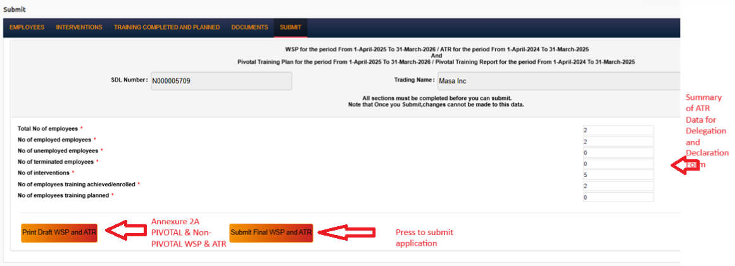
The official email address for all mandatory grants related enquiries is wspdocs@serviceseta.org.za
All skills development facilitator profile related enquiries must be sent to application@serviceseta.org.za and cc wspdocs@serviceseta.org.za

